**Directions**

In your group you are expected to collaborate on addressing each question. If you are the first person to post your ideas, do not fear! This is intended to provide you with a safe space to put your ideas on paper.

If you come to the document and there are ideas that you disagree with or would like to revise / clarify, feel free to use comments to discuss with your group members.

My hope is that each group member contributes equally, but that may look different for each person. I expect for each of you to edit and add to posts from the rest of your group. This **is not** an individual assignment, so please don’t write individual responses and fail to engage with your group.

Your final responses are due on Friday, January 8 by 11:59pm. You will be required to download this Google Doc as a Word file to submit in Canvas. Only one submission per group is required.

**Question(s)**

1. What do you believe are similarities and differences between Statistics and Mathematics?

|  |  |
| --- | --- |
| Differences | Similarities |
| * *Deeper levels of Mathematics tend to be more theory based whereas Statistics involves analyzing* * *Math involves proofs (things seem to be more black and white)* * *Math also does not deal with probability/ uncertainty/ or ambiguity, whereas Statistics does* * *Statistics is much broader and left up to interpretation of measurable data (changes depending on how the data fits a model)* | * *Data analysis* * *Problem solving* * *Mathematics is used in Statistics to determine similarities and differences* * *Both are used to understand and model the world* * *Involve using numbers* * *Both utilize mathematical formulas* |

1. From your perspective, what is Statistics? Is there a difference between “statistics” and “Statistics”? If so, what?

*Statistics is the study of different data sets, via analysis, interpretation and collection. It allows for individuals to make connections and possibly infer information about the whole group given a sample.*

*If there is a difference between “statistics” and “Statistics” it was never something most of us have noticed previously. At this moment, the only difference between the two is whether one is using the word as a title or start of a sentence compared to using it as a description or in the middle of a sentence. One possible difference between “statistics” and “Statistics” could be that the lowercase word means computations and analysis whereas the uppercase could reflect the study or as a whole. Another possible explanation could be that Statistics is the mathematical discipline itself like the subject of math, whereas statistics are (may be) the quantitative data such as mean test scores.*

1. Just because a variable has numeric values, does not mean it is a numeric variable. What are the different types of variables that can appear in a dataset? How can you determine if a variable is numerical versus categorical?

*The types of variables that can appear in datasets are numerical, categorical, ordinal, discrete, nominal and continuous. Numerical variables are quantitative and measurable (ie. 1000 units of measurement). Categorical variables are qualitative and describe a property of something (ie. "red" for colors).*

1. What are the differences between observational studies and experiments?

*Based on previous course knowledge experimental studies are where the experimenter interacts with the different groups (experimental, control). On the other hand, observational studies are when the experimenters are not having interactions with the study and usually lack bias compared to experimental studies.*

*After the reading, our understanding has grown. Observational studies lack interference from the researcher during data collection. Observational studies can be used as evidence towards recognizing naturally occurring association between variables and can not depict a causal connection. In other words, observational studies are utilized to determine if there are any naturally occurring associations between variables. Whereas an experimental study is composed of researchers who test an explanatory and response variable to determine the causality between variables. Therefore these studies are composed of different sample groups with certain variables being controlled by the experimenters. With experimental studies, a placebo or fake treatment is sometimes used to determine if a drug or treatment actually works. So, experimental studies have a possibility of determining a causal connection.*

1. What are different methods for sampling from a population? Why would a researcher choose a stratified random sample instead of a simple random sample?

*The different methods of population sampling are: simple sampling, cluster sampling, stratified sampling, and multistage sampling. It is important to note that convenience sampling is a type of possible sampling bias, not necessarily a method of sampling.*

*A researcher would probably choose a stratified random sample when they want to see a relationship between multiple strata because then they could compare the subgroups within the population. To add on, it is useful when the cases in each stratum are very similar to the outcome of interest. If done correctly then it also helps the researchers end up with a more accurate representation of the whole population because of how they classified it.*

1. Describe what you see in the plot below. 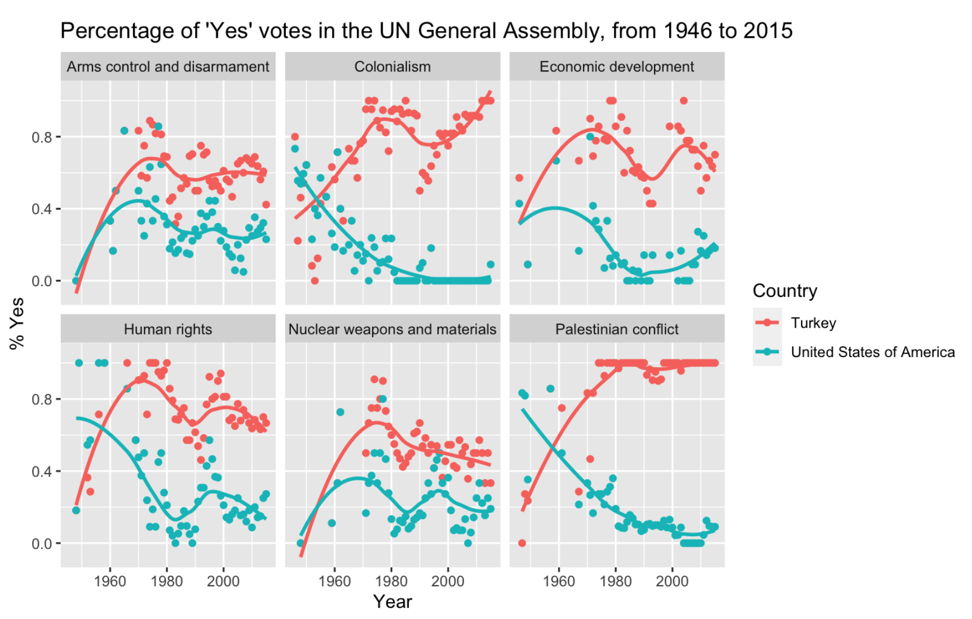

*The above figure depicts a scatter plot because there are two numeric values: the year and the voting pattern of countries in the UN General Assembly during the same year. The votes were also categorized by country between Turkey (red) and the United States of America (blue). In addition, the figure includes multiple scatterplots that are related to specific issues: arms control and disarmament, colonialism, economic development, human rights, nuclear weapons and materials, and palestinian conflict. From the data charts we can see that the line of best fit generally follows the prevalence of yes cases. It can be shown that the percentage of “Yes” votes in the UN General Assembly between 1960 to 2015 is higher for Turkey than the United States of America for all political issues. However, we cannot confirm if it is significant unless we run a statistical analysis.*